Comp3721 Assignment#2

- Assume TDM is used to interleave data streams from a number of 110bps asynchronous terminals over a single 4800 bps digital line. The terminals transmit 7 data, 1 parity, 1 start and 2 stop bits per character. Assume 1 synchronization character is sent every 19 characters and 3% of the line capacity is reserved for pulse stuffing to accommodate speed variations in terminals.
- What is the effective data rate in bps?
Async = 110bps Line = 4800bps Data_char = 7bits Total_Char=11bits
Stuffing = 3% Sync = 1/19 => Sync = 5.26% Total_Inefficiencies = Stuffing + Sync
Total_Inefficiencies = 8.263% Efficiencies = (100%-Total_Inefficiencies)*Line
Efficiency= 4.403*10³bps

Data_Rate = Data_Char/Total_Char*Efficiency = 2.802*10³ bps

- How many terminals can be accommodated by the TDM multiplexer?

Terminals = floor(Efficiency/Async) = 40

- Assume that four 600-bps, eight 300-bps and an unknown number of 150-bps terminals are time-multiplexed over a 9600 bps line. Assume 10 bits/character, 1 synchronization character inserted every 99 characters, and 3% of the line capacity allocated for pulse stuffing to accommodate variations in terminal clock speeds. How many 150 bps terminals can be supported?

Async1 = 600bps*4 = 2.4kbps
Aysnc2 = 300bps*8 = 2.4kbps
Stuffing = 3% Sync = 1/99 Sync = 1.01%
Total_Inefficiencies = stuffing + sync = 4.01%
Data_Rate_Used = Async1+Async2 = 4.8kbps
Line = 9600bps
Efficiency = (100% - Total_Inefficiencies)*Line = 9.215kbps
Unused_Data = Efficiency – Data_Rate_Used = 4.415kbps
Async3 = 150bps
Terminals = floor(unused_data/Async3) = 29

- Two stations wish to communicate over a network. There are 4 hops required to get from station to station. The data rate on all links is 9600 bps. Message length is 3200 bits. If packet switching is used, each packet size is 1024 bits which includes 16 header bits. Call setup time is 0.2 seconds. Calculate the total end-to-end delay for:

- Circuit switching
- Message switching

- Packet switching

Assume no delay at the nodes. Use the following variable names for deriving your delay equations:

N:# of hops between two given stations
L: Message length in bits
B : Data rate, in bps, on all links
P : Packet size in bits
H : Overhead (header) in bits
S : Call setup time (CS or VC) in sec’s
D : Propagation delay/hop in sec’s

QUESTION3 REMOVED FROM ASSIGNMENT – ADDED TO ASSIGNMENT#3

- A simple telephone system consists of two end offices and a single toll office to which each end office is connected by a 1-MHz full-duplex trunk. The average telephone is used to make four calls per 8-hour workday. The mean call duration is 6 min. Ten percent of the calls are long-distance (i.e. pass through the toll office). What is the maximum number of telephones an end office can support? (Assume 4 kHz per circuit).

Each telephone makes

Num_calls = 0.5calls/hr Call_duration = 6min/call
Circuit_Occupancy = Num_calls*Call_duration = 3min/hr
20 telephones can share a circuit

Since 10% of the calls are long distance, it takes 200 telephones to occupy a long-distance circuit full time

Num_Tels = 200 phones/circuit

Circuit_bandwidth = 4kHz/circuit
Trunk_bandwidth = 1MHz
Circuits_per_trunk = 250 Circuits
End_office = Num_Tels * Circuits_per_trunk = 50000 telephones

- A modem constellation diagram has data points at the following coordinates: (1,1), (1,-1), (-1,1) , and (-1,-1). How many bps can a modem with these parameters achieve at 1200 baud?

There are 4 legal values per baud, so the bit rate is twice the baud
- data_rate = bits_sample*samples/s = 2400bps

- A noiseless 4-kHz channel is sampled every 1msec. What is the maximum data rate?

A Noiseless channel can carry an arbitrarily large amount of information, the sample rate notwithstanding. Just send more bits per sample

The keyword here is “noiseless”. On a normal 4kHz channel, the Shannon limit would of course limit the amount of data sent

- Is the Nyquist theorem true for optical fiber, or only for copper wire?

Nyquist thm is a mathematical property and is not subject to change by technology

It simply states that if you have a function whose Signal (Fourier) Spectrum does not contain any sines or cosines above “f”, then by sampling the function at “2f” we can capture all the information it conveys

Thus the Nyquist thm is true for all media

- Do questions 15 and 17 in chapter 4.

15. Bandwidth is proportional to (3/8)N which is within the range in
Table 4.1 (B = 0 to N) for the NRZ-L scheme.

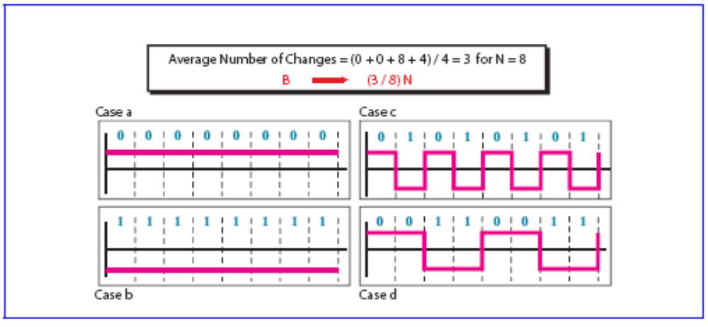

17. Bandwidth is proportional to (12.5 / 8) N which is within the range
in Table 4.1 (B = N to B = 2N) for the Manchester scheme.

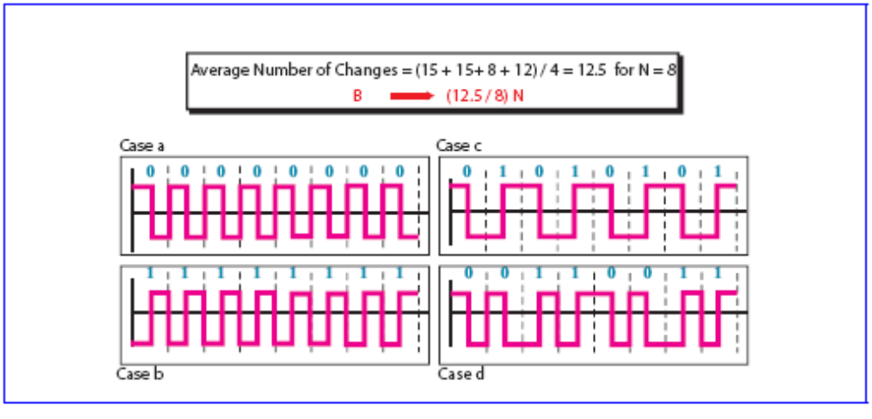
- A satellite transponder operating in a region has a bandwidth of 24 MHz. The channel beam achieves a 12 dB Signal-to-Noise ratio
- Determine the maximum bit rate on the channel given the above information.

C = (24*10⁶)log₂(1+15.8) = 97.7Mbps
- Now assume that the signal used to encode the information has a baseband spectrum of 60 kHz to 4892 kHz. Determine the baud rate that will be required to support the bit rate found in (a).

C = 2Hlog₂L
=>97.7*10⁶ = 2(4892*10³)log₂L
L = 1013.9 levels or practically 1024 levels because we have 9.98 bits/baud ~ 10bits/baud
Baud rate = 97.76*10⁶/10 = 9.77*10⁶ baud

- Calculate the Signal-to-Noise (in dB) required to support a bit rate of 500 Mbps for this system.

500*10⁶ = (2.4*10⁶)log₂(1+SNR)
SNR = 62.7 dB

- Given the SNR in (c), determine the maximum allowable noise power on the channel to maintain the required bit rate. Assume that the signal power is 35W.

62.7dB = 10log(35/N)

N(noise) = 18.8*10⁻⁶W

